Molly Faulkner, Wayland Historical Society, January 10, 2016
TALKING TRASH! GETTING RID OF WAYLAND’S REFUSE

Thanks everyone. I have always had an interest in social history, the details of everyday life in other times, and thus my interest in how people deal with something very ordinary, and ever present -- TRASH. I could have just as easily written about what people ate and how they prepared their food, or, what were the “consumer purchases” of the 1880s factory worker in Cochituate or farm hand in Wayland. Interesting topics for another time!
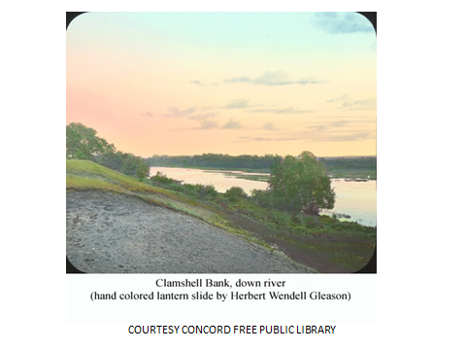 Between 8 and 1000 years ago people called "Settlers" walked the shores of the Musketaquid collecting fresh-water clams, making tools, cutting with axes, hunting game with spears, grinding food with stone pestles, and cooking with soapstone pots. They ate plants, game, and fish, and many turtle species. They moved up and down the rivers bringing salt-water clams from the coast .
Then there were the “Farmers" who lived between 1000 and 350 years ago and moved from summer on the coast to winter inland. Using brush and rocks, the people made weirs to catch fish in brooks. They planted corn, beans, and melons on valuable, well-drained, fertile agricultural soils. They ate wild rice, cranberries, and nuts in the autumn. These Farmers wore stone pendants, ground with pestles, collected firewood, cooked with clay pots, cultivated crops with pointed sticks and hoes, cut trees, made dug-out canoes, and shot game with bows and arrows. Whatever remained of their organic tools or artifacts disintegrated quickly in the acidic and oxygenated water and soil – except for those found in the famous Concord Shell Heap –now an ignominious finish as a paved parking lot at Emerson Hospital. 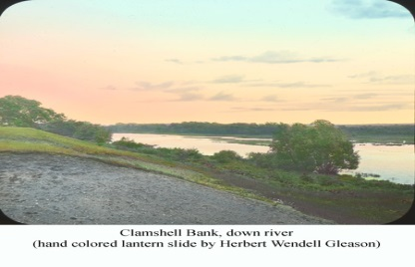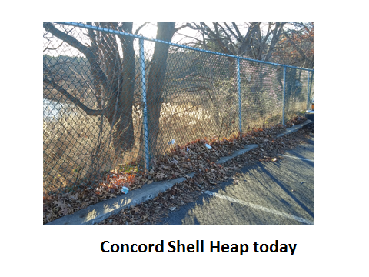
Clamshell Bluff or (Concord Shell Heap) was a seasonal camp on the banks of the Sudbury and as a camp, contained a trashpile or midden and trash pile -- for all these peoples.

Benjamin Lincoln Smith, an archaeologist and Concord resident who excavated the Shell Heap site wrote: “When they put the bulldozers there I was right with them. Right in the middle where Route 2 comes across the bridge and starts up the hill towards West Concord, a big fireplace was found. …At first I thought they were skulls, but they turned out to be turtle shells.” Indians had eaten vast numbers of snapping turtles that they had caught in the river as well as mussels—the shell heap also held the bones of muskrats and beavers who liked to feed on clams as well as bones of deer, turkey and fish cooked nearby. There were also an abundance of round stones from the coast - The Indians used to go to the salt water beaches and pick up good, round, solid stones and use them for hammers because the ordinary field stones that they would have around here would splinter.

Archaelogist Shirley Blancke and historian Brian Donahue constructing the local prehistoric record of human culture near WP wrote: the clamshell bank or Concord Shell Heap site is the closest thing prehistoric Concord (or Wayland) has to a pharaoh’s tomb, it being the only inland shell midden in New England. The midden dates to 4500 years ago when pollen record indicates a pine-oak forest similar to that of today.

And this is how it worked as Tonya Largy of Wayland Archaeology told me : Because of the calcium-rich shell environment, broken or lost tools have survived well in the Shell Heap. As early as 1832, Lemuel Shattuck had noticed “many hatchets, pipes, chisels, arrow-heads, and other rude specimens of their art, curiously wrought from stone,”…

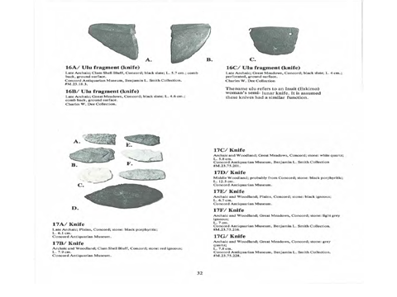 2 knives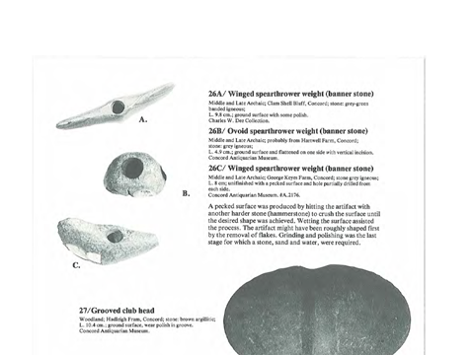winged spearthrower weight 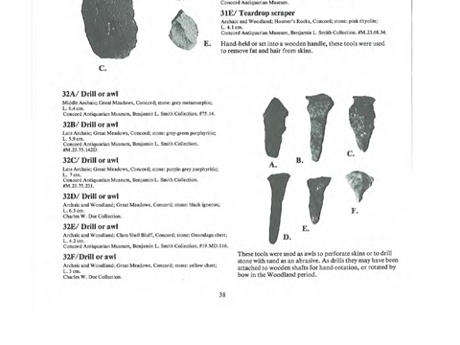drill or awl
And, long before that time, colonial Americans were leaving their piles of discards upon the land in the form of filled in privies – great sites for finding plates, pipes, buckles, bottles, etc.

I’m going to venture to say that not much changed in how most of Sudbury, then East Sudbury, then Wayland’s residents dealt with their refuse through the years – that is, until about 100 years ago.

People pretty much took care of their own stuff: food scraps were fed to chickens and pigs or dug into gardens. Ashes were buried in low lying places or used to make soap. There weren’t really much to throw away. In the last century and before, farmers would fill in ditches with rubbish and junk. Mike Lindemann of the Parks department, grew up on Riverview Circle and said everyone buried anything of any size as well as ash from burn barrels in depressions in their land…. When basements were cleaned out, into the ravine it went…if someone was getting a new septic and had a bunch of extra fill, they’d then cover the dumped items. If you didn’t have a handy ravine or ditch or stream then you would take the big items to the dump on Main Street – mattresses, bed frames, couches. But the dump on Main Street only opened in 1935 – and DPW guys keep running into earlier dumps when they dig, e.g. DPW ran into a huge bottle dump and burn area at Hannah Williams and there was coal ash there; plus places at Lakeview Cemetery at the old nursing home area; when Ed Lee would use a backhoe, he’d often find old dumps, some with lovely old bottles, toilet bowls, in any gully.
Ed Lee recalls a dump (for the locals) right in the Mill Stream, just below the old ice house and he’d look for bikes there. The old icehouse was still in use and he would bring ice to the Paine Estate (now Traditions).

And in a cellar hole behind Lee’s farm stand , Ed found lots of pieces of shoes….he thought came from the factory in Cochituate. Old cars were often buried to fill in holes. There are three cars in in the Pine Brook conservation area that generations of Bennett Road kids have enjoyed.

So people used natural made holes for trash burial, used the town dump when available, but they also burned.
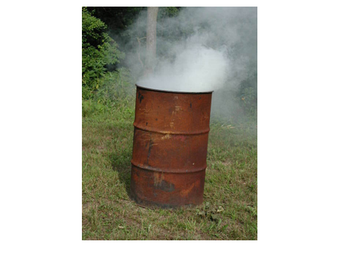I’m in my early 60s but remember a burn barrel in our Berkshires house – like others, we buried our glass, cans and food and burned paper and cardboard. Bill Parker’s grandfather (Bill at our transfer station) would go to the old Harvey’s burn area and pick up all their leftover burned cans, dig a long shallow trench, lay them out and squish them with a car tire, then recycle them in Worcester for very little money.

Junk metal was picked up by a junk metal dealer who resold it.

Backyard burning wasn’t particularly harmful for anyone then - not when you’re talking about untreated paper and wood. But by the 1970s, our garbage contained paper, plastics, and other types of packaging waste that released a hazardous mixture of carcinogens and other toxics (such as lead, mercury, and arsenic) when burned. Even seemingly harmless items, like paper, mail, packaging, and cardboard boxes used for frozen pizzas and vegetables, give gave toxic emissions. Dioxin has significant impacts on human immune, developmental, and reproductive systems. Dioxin produced by backyard burning is deposited on plants, which in turn are eaten by animals. In fact, over 90 percent of all human dioxin uptake comes from meat and dairy consumption. …… The U.S. EPA estimates that one burn barrel (from an average family of four) can produce as much or more dioxin as a full scale municipal waste incinerator burning 200 tons per day. Burning garbage in burn barrels or fire pits creates low temperature fires which receive very little oxygen and produce a lot of smoke. While there’s likely no burn barrels operating in Wayland, you can certainly find them in less affluent towns w/little services or poor oversight. Outdoor burning at home was prohibited.

Plastic? There really wasn’t much: Even in early 60s – no plastic shopping bags. At First National near McManus’s where Ed Lee would go for essentials, they’d write up the “receipt” right on the bag…no waste. Now, when computer shuts down, the store closes.

Here are some examples of our packaging problems:
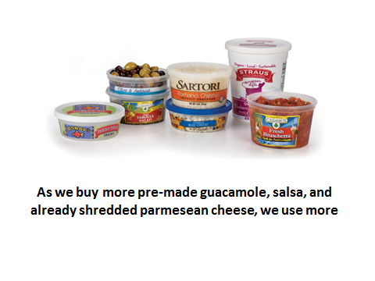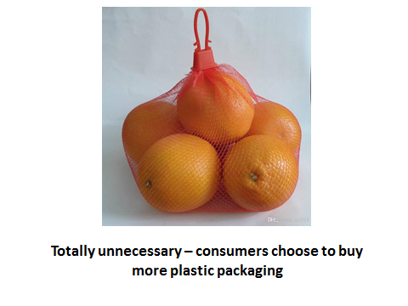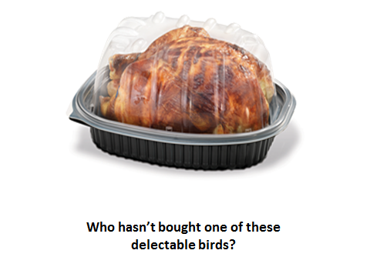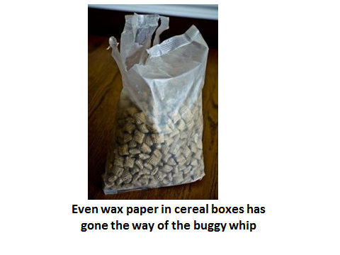

Mike Lindemann’s parents only generated a small bag of trash per week!

TWO BIG CHANGES AT ONCE: HUGE POPULATION GROWTH AFTER WW II AND CHANGE IN FOOD HABITS

Not only did the kind of trash change but the population of Wayland grew fast, attracting people from the cities…..

Who knows the difference between garbage and rubbish? Yes, garbage was food scraps and rubbish was everything else that you wanted to get rid of. When people cooked from scratch, canned and preserved a lot of their own food, returned cider, beer and coke bottles for refills, there was little trash. As more of us bought and ate more packaged foods, there was a marked increase in trash and decrease in garbage.….– no more ends and bits and peels and pits – just containers and wrappers.

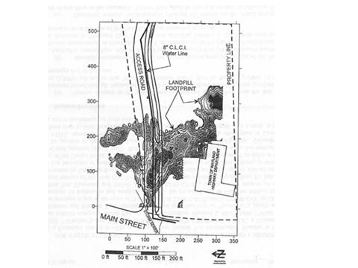For Wayland’s dump, garbage was not welcome as it attracted rats……and for those families who did not own a few pigs of their own, garbage collectors hauled it to a shrinking number of pig farms. But more on that later.

MAIN STREET DUMP
When Ron Profit was a kid, he and his friends hung out at the dump; opened in 1935, there was less need for a central dump in north Wayland with less population. When Ron was young, he’d go picking at the dump on Main Street and get bottles to return to return to package store by DD. (2cents/bottle). That was extra income.

Joe DePaolo (of BP Trucking), younger than Ron, remembers guys going there at night to shoot rats w/.22s…he didn’t like that at all. Janot Mendler says she used to squabble with her sister over who got to go to which St. Peter’s – one, being church with her mother, the other being the dump with her father, who coined the joke because the fellow who ran the Wayland dump on Main Street was named Peter. Peter Lagasse who also tended the first dump on Route 20.
There was lots and lots of burning there and there were few houses in the area adjacent and behind the dump. The Road Commissioners met in the old DPW building. When the DPW considered moving out the fuel depot about 15 years ago and did some digging, it was evident to everyone just how much had been buried there. And burned there. And while this report shows most of the debris being buried to the right of the access road, people who remember this dump keep telling me that the main area was off to the left… Hum.

By the late 50s it became apparent that a new location was needed and the town leaders closed the old dump on Main Street in 1958 and a new one opened up along Route 20 just after you cross the Sudbury River on the left. There was probably some overlap as some Waylanders continued to use the old dump while Cochituate folks enjoyed the salley, “Oh yes, we used to go to Wayland every Saturday – to the dump that is.” Din Egan took his collected trash first to Cochituate, then to Route 20, “where they buried a horse or two up there” there was so much room. And someone told me that the new dump was close the bridge - a favorite place for farmers to dispose of kittens.

Here’re a series of pictures from the old Route 20 dump – each better than the last:
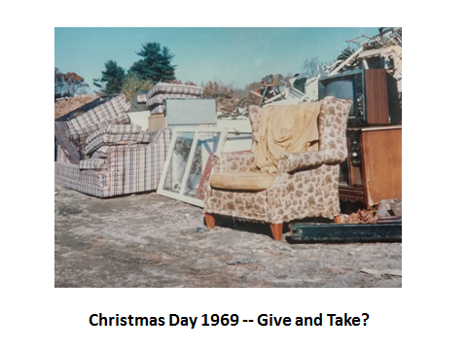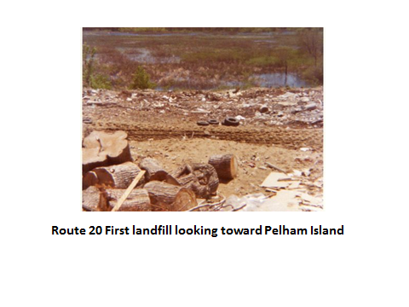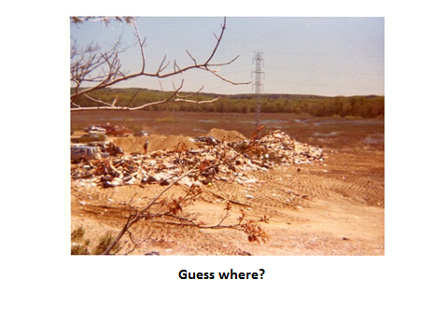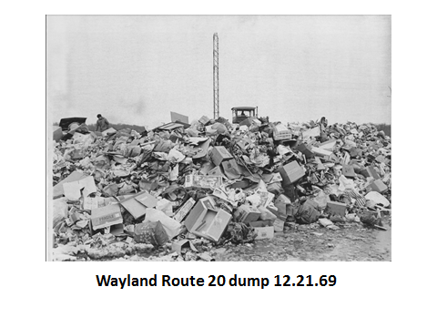

Rt. 20#1

Pete LeGasse ran an “open” dump so anyone with car and truck could come in…..Sometimes the big guys rubbish haulers came in after hours, but so did some of the small one haulers like Ron Profit’s. But the bigger haulers had packers, which really held tons of stuff, really took up lots of room. Dump the trash into trench and Pete L. would compact it. Mike Lindemann in the parks department would walk and ride bikes up from Riverview via Landham and walk along the tracks to the dump which ran all the way over to Richey and Clapper (then Raytheon) -- looking for engines for their minibikes.

By 1965 that dump was running out of room and Mass DPH suggested that the town find a new site instead of using an additional 10.5 acres between the present dump and the Sudbury River – that doing so will cause serious pollution of the river. 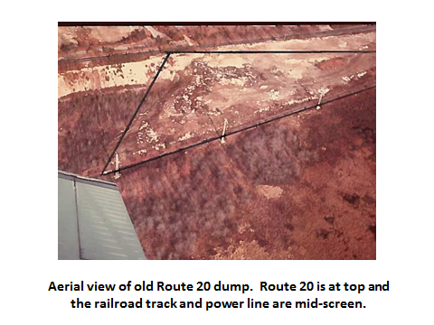

But by then there were real problems anyway. When flooding occurred stuff would float away. Working conditions were grim with no running water and when people there complained about no toilet – the RC’s response was, well, just be careful where you go. It was a throw your trash and bury operation, then changed to a burning operation in trenches in mid-late 60s

In 1965-66, the Board of Health received complaints that Arena Bros. were dumping garbage at our fill. In 1966 Mass DPH said repeated inspections showed a dump “on fire” – obviously not a “sanitary” landfill. There was talk then about joining w/Sudbury to build an incinerator but they decide to go the Sanitary Landfill route in 1969….

Bill Parker at our transfer station ran the landfill in 69-70 in Wayland bfore leaving for a job closer to home. Said in 1970 they bought a “landfill compactor” which mixed dirt w/the trash to hasten decomposition (others, like Northboro, they just crush it and that’s when you find pristine newspapers 30 years old) It was called a Hyster, instead of a roller, it had knobby wheels that would really compact the trash.

In July 1970 new regulations re open burning sharply reduced the life span of open town dumps.
‘
And, by this time, alternatives to landfills were considered. According to a Boston Globe article in 1972, “limited space…communities seeking new dump sites now face still competition from private industry attracted to the low-lying, often swampy areas formerly considered of little value. …Regional incineration is considered a money making proposition by private constructors – there will be massive facilities in Saugus and East Bridgewater. “

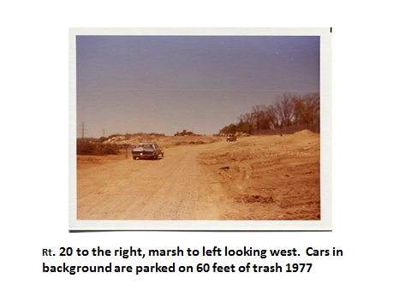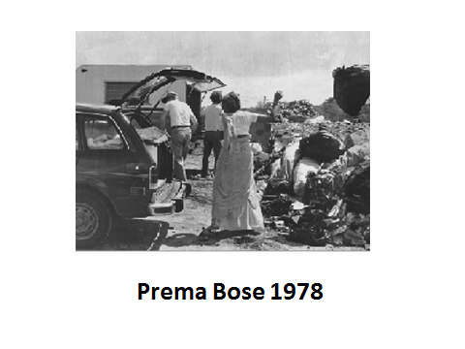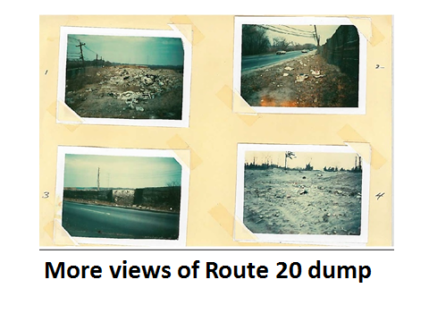
As you can see, the first Route 20 dump was not an inviting entrance to the town. Charlotte Russell with her Camp Fire Girls….decided to help beautify Route 20 by planting forsythia between the dump and the road to hide the ugliness. The girls were so proud. But when the road was widened it wiped out most of them… Another idea was was to make our own “Mt. Trashmore” like that one in Virginia Beach, complete with a marina on the Sudbury. Dirt dredged out for the marina would be used as fill to cover to elevate the dump even more. But, there wasn’t enough room between the river and the road to build a Mt. Trashmore
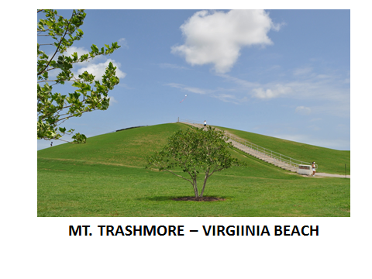

WATERTOWN DAIRY
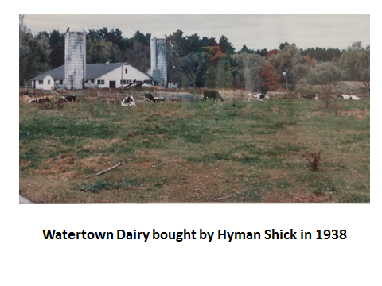Some residents found even these regulations a little restricting. Hyman Shick come to Wayland in the 1938, moving his family’s Watertown Dairy operation to Moore Road – a 250 acre site. When, in the late 1970s, Shick’s farm was foreclosed, SVT and the FHA worked out a deal conserving about 100 acres to become, eventully, the Sedgemeadow conservation area and federal wildlife refuge land. For some time, the US Fish and Wildlife service was buying up wetlands -- about 50-60 acres were not considered wetlands and became a number of huge new residential properties. However, a 200 x 250 x 4 foot area dump was discovered full of rubber scraps from American Biltright, 0-8’ below grade, near the Sudbury flood plain. A 30 x 35 foot area contained glassware, needles, medicine bottles (w/remnets), petri dishes, bottles of blood from Harvard…The dumping likely occurred 1968-1975… Shick may have needed money to keep operating and this was one way to pay the land work for him.

Shick’s brother in law, Therodore Barron, a former Chelsea junk dealer, worked for Sanitas waste hauler. He ran the illicit cash operation, spending up to $180,000 a month for illegal and cut rate dumping in MA…A SEC witness said cash was paid to dump at the Watertown Dairy in Wayland to use dumps in Methuen, Qunicy, Chelsea and Randolph – to dump operators and on occasion to employees at the entrances. In MA, the cash rate for dumping was $13 a load compared to $70 if paid by check. Sanitas determined that their gross profit margin would decrease from $246000 to a mere $10000 annually w/out cash payments.

Barron said there were only two places in the Boston area to dump flammable material and said the company had been going to Watertown Dairy for this purse and that it worked out well… Another employee testified that employees at Goodwill, Boston Woven Hose (Biltrite) and Harvard University were given cash in return for getting and keeping contracts, including $4000 to Harvard. This is some of the property now:
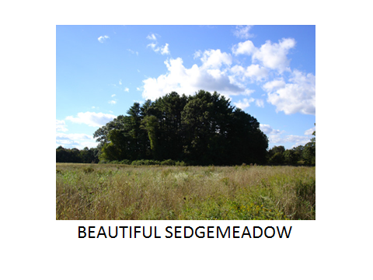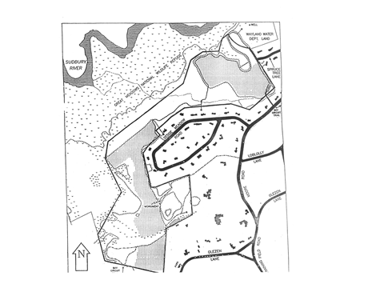
.
Meanwhile there was other dump sites in town, some sanctioned, some ignored – not at either of the official landfills:

Harry Williams of the Road Commisions was dumping at Stonebridge Sand Pit even though there were town wells just adjacent. Stumps, concrete, metal and bituminous debris (10 wheelers from Mass Turnpike work), dumped there. BOH issued a cease and desist order in 1978.

Septic tanks were emptied on agricultural fields……e.g. Damon Farm before houses were built…. The septage facility was built in the mid-70s.

Route 20 #2
By 1969, the town began looking for a new site and so looked across the street. Most of that 24 acres was a former gravel pit and while town people knew it lay on the Baldwin Pond acquifer they thought it was “probably” isolated by a clay layer. Town officials felt the heat of the baby boom – and were told by Camp, Dresser and Megee that Wayland’s population would be 22,000 by 1990 (wow, were they wrong!). They needed more space.

The new dump Opened 6/30/80.

But by mid 1980s, there were difficult times for the new landfill. The 70s had seen a long history of complaints between the BOH and the Road Commissioners; now they were tangling over problems with clay liners and expanding this landfill. Expansion was chosen as more cost effective than sending our stuff away…other choices were: joining together to build a WTE incinerator (most expensive) with Sudbury, building a transfer station and taking it to another town; and get out of the business entirely and letting residents do it on their own with private haulers – the most costly option for residents.

The trash management industry people complained that commercial trash haulers had no place to go… They were being shut out of town dumps and landfill fees were doubling and there was lots of local opposition (citing home rule) to new landfills sites.

Some said the state was less aggressive in monitoring landfills because closing them would eliminate precious space needed now; and so landfill operators were routinely taking in more daily than permitted, aggravating water contamination. In 1984 the DEQE had only four inspectors to survey landfills, and only one full time engineer to monitor compliance. The legislature allocated no money for solid waste enforcement even though money was allocated to hazardous waste.

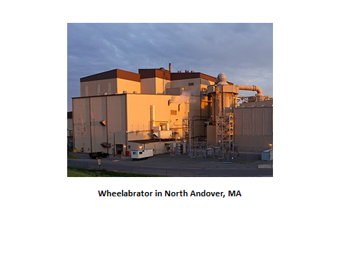WTE or Resource Recovery plants were likely better than their predecessors – incinerators. The Millbury plant, completed in 1987 burns at 2500-3000, heating water, forming steam, turning turbines to produce electricity. Trash is reduced 90% in volume and 75 %in weight…using less landfill space. However, these plants produce dioxin and heavy metal residues; the dioxin laden ash is buried in landfills.

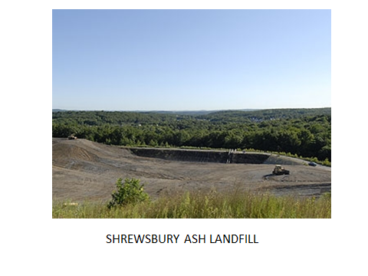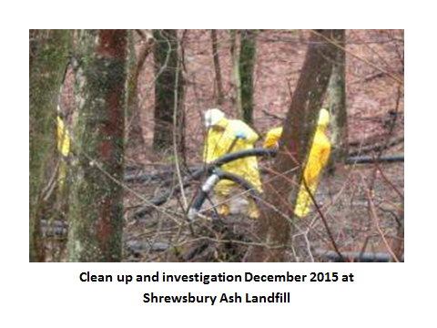
Heavy rain in December 2015 heavy rain flooded a holding cell causing 3-4,000 cubic yards of ash to run into nearby wetlands and brooks, equivalent to 350 10- wheel dump trucks. They were still vacuuming the areas in early 2016.

About this time recycling across the state really ramped up --- to a large degree because we didn’t have landfill space; towns hoped to divert as much as 50% from the landfill or incinerators.

Tires were always a problem in landfills because they often don’t stay buried and pop up through the cover. There began an industry to shred and process the rubber w/asphalt for road paving. Tire recycling really go underway in 1987 w/6 million tires processed in MA.

In Wayland, in 1988, this is what we were recycling: newspapers, glass, batteries, and scrap metal e.g. refrigerators and cans…we thought there’d be another 10-15 years of life left to our landfill. In 1989, Wayland invested in a roll-off hoist truck and containers….and in 1990, town was recycling about 24% of the waste stream; By 1990 we added paper, cardboard and magazines; plastics (milk, water and detergent):

Mixed newspaper, paper and magazines; mixed cardboard; one for clear glass, one for green and brown glass; and plastics (milk, water, detergent).

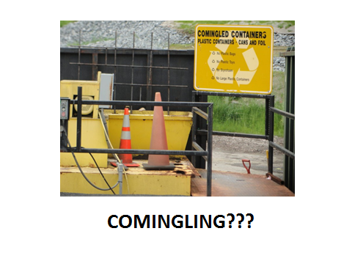I’m not entirely sure when we got into comingled recycling which meant the unnatural act of putting cans and plastics together; the start of the process toward zero-sort or single-stream recycling later. I believe that almost to a person Waylanders who used the Sudbury transfer station and Sudburians who used the Wayland transfer station preferred Wayland’s layout and ease of use. Sudbury reminded us all of how difficult recycling could seem.

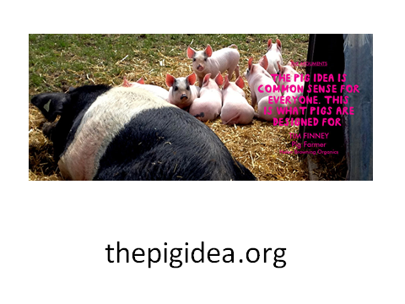
Garbage collection

I’ll bet some of you remember hearing about what happened in Cairo and Alexandria when Egyptians closed the piggeries operated by the Zabaleen or Garbage People, Coptic Christians, in 2009 for a variety of reasons; the overwhelming mess that resulted led to their reopening four years later. Pigs, in Egypt, eat as much 80% of rubbish – the rest of which goes to landfills.

Well, until last mid-century, many rural people had a few pigs and chickens on their property for just that reason….a perfect animal machine for processing food scraps and becoming eventually a meal in itself. Ed and Dottie Lee got a small piglet from Tommy Hynes on Old Sudbury Road and Petunia lived until the fall on Wallace Road when she became dinner. Bob Dorey told me that Tommy Hynes farmed all over Wayland, including around Folsom Pond Road, fields behind Peace Lutherin, Mrs. Sanderson’s house on Glezen, and also on the land owned by Divincents on Plain Road raising produce and corn for Pinkey’s on Route 30.. He’d use a bucket loader to bring home leftovers and would also feed His two or three pigs garbage from Lobster Haven—would always feed them well before the slaughter. Din worked for Woodward’s chicken farm inoculating and would take dead ones to Hunt’s .. “them pigs knew when they were coming and they’d get all wound up and fighting, like a Saturday night at the Chateau.” And, now you know -- pigs, and chickens, are omnivores.

And that pig manure? That was spred on the broccoli fields at 9 acre corner where Verrill Farms are now…

But for those of us without a couple of pigs in back, there was the garbage collector. Remember, most residents had a GROUND HOG near their kitchen doors. Garbage was NOT rubbish – Tom Sciacca told me that when he and Jane moved here from the city, they were shown where the in-ground garbage pail was and proceded to stuff everything they could into it, wondering why the garbage man wasn’t getting the pail as well as the extra that wouldn’t fit in – a neighbor clued them in! Each week, once in the winter, twice weekly in the summer months, the garbage collector would make his rounds, along with the milk man – walking over to the place, pulling up the pail out of the ground, dump it into a 55 gallon cans on the back of his truck and replace it. The town of Wayland had contracts with a number of haulers – once was Robert Starret from Mendon who had the contract for at least 4 years in late 50s, early 60s. He had at the time about 3,000 customers but even then was complaining that there was not enough demand for garbage or swill amongst the pig farmers.

A number of people picked up garbage: CO Baker in Cochituate, Dim Egan’s father Bill picked up swill in Wayland – that’s how he met Dim’s mother I was told. Ralph Shanley used to pick up garbage in 55 gallon barrels on the back of his truck, tipping them off at the Cavicchios – what a heavy job!—which used to be two separate farms. The greenhouses and vegetable farm bought out the pig farm in back.

Small farmers would collect from others directly – George Lewis’s garbage was picked up by a farmer on Glezen.

And the collected garbage was delivered to piggeries – love that name! There were a number of big piggeries in the area. A Weston man named Hunt had a big operation in a swampy area behind the Tower Hill station where there several large houses now; he also had a rendering plant in Weston on Love Lane. George Lewis wrote that the Lokers had a large one where the school now stands and Ed lee said there was a small pig farm on off Main Street south of Dudley Road. Garbage was also taken to Shick’s Watertown Dairy farm as well as to Tilson’s Farm (about where Mel’s and Mobile and office building are on 30). Also, there was Aubrey Bordon’s farm about where the BMW place is and that is where the Russell’s garbage was taken for a while.

A number of things conspired to do away with the garbage man:

- Development and growing population led to a 20% drop in number of piggeries in Mass between 1963 and 1973 and a 32% reduction in number of pigs. Take the town of Bolton for example: In early 1980s, like a lot of dotcom communities that were springing up, pig farmers were targeted by neighbors who wanted to put them out of business. Froom 1968 to 1983, Bolton households increased from 478 to 790 and population grew by more than a third and virtually all of that growth was from professional commuters. Many new houses were built next to farms, some of them pig farms. Anti pig forces demanded BOH hold up issueance of new permits and renewals of old one until regs could be revised and BOH refused; they then filed for injunction in Wordcester Suerpoieror Court but were denied. They they filed an appeal in Superior court. Still pending in 1983. So they collected enough signature to force a special town meeting. And lost.

- The Mass Animal health inspector said in early 70s that the quality of home garbage was deteriorating with the proliferation of packaged foods. A 1950s dinner of peas and fish would fill the garbage pail with peapods and fish heads, but now it’s just an empty can and paperboard. And that pig farmers were turning to leftovers from the very companies making processed food for us!

- Growth of incinerators: Communities w/incinerators generally combined garbage w/their rubbish collection and were often moved to do so to save the town money.
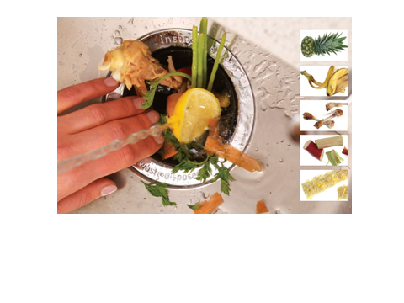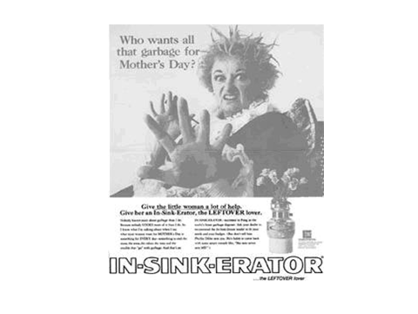

- Also disposals – here’s Phillis Diller expressing how she feels about garbage – Every new house seemed to come with one which was not exactly the best thing in Wayland with our septic systems: people and pumpers tend to toss the effluent t-filter because it gets clogged w/food unless cleaned twice a year because its size has not kept up with the growing size of the system; if it’s gone then the life of the septic really suffers. And regardless, when the septic system is installed you need a septic tank w/twice the capacity and a septic field 50% larger than if no disposal. And while pumping is only typically necessary every three years, it’s recommended annually w/a disposal.

LITTLE GUYS TO BIG GUYS IN THE RUBBISH BUSINESS
Ralph Rogers and Charlie Philipo were among the first to pick up rubbish (no garbage) – Charlie’s son said he had a truck with a palette and sign saying “Garbage or Rubbish by Charles” or something like that. You may know, or not, that there seemed to be quite a nice connection in Wayland between the Fire Department and the garbage and rubbish business – in the old days. As Ronnie Profit told me, firefighters worked two day shifts, two night shifts and four days off, so easy to augment. Eventually, it became 3 days, 3 nights, off 3 days Ronnie Profit: the P in B-P trucking. Ronnie trained as electrician in Newton but went into rubbish business in 1962 with Ralph Shanley – shows common carrier plate from the DPU – you could have three towns for pickup. There’d be big guys staking out their areas – the small guys could have leftovers and have three towns….
George Butler joined two years after he came to the fire department. There were established big boys from Natick/Framingham in Cochituate, so they went first to people they knew to put the word out; Joe DePaulo, also a Wayland firefighter, eventually bought B-P.

Joe: BP started in ’65 w/dumpsters for commercial pickups and were allowed to dump in Wayland’s landfills if trash came from Wayland residents . Now, with landfill closed, their rubbish goes to Hudson when BP runs a big transfer station as well as the dump etc. for the town of Hudson.

So, what’s left? COMPOSTING!

In 1990, leaf and yard waste made up 20-30% of all household waste.

Town has been Composting at Lakeview Cemetery for years, before Mike Lindemann started in 1977. From the leaves collected on town property, mixed with manure from Randy Hill 3x/a year (30 cubic yds at a time) they produce 2-4000 yards per season, and use 1-2000 years/season on fields, tree planting. Paying 1.60/yd vs. 20/yard to buy it. IS TOWN STILL DOING THIS IN 2017? In years past, the town would pick up manure from Watertown Dairy, from the riding rink on the Paine estate, and from an older house on Rice Road--- hundreds of yards from that one. The town tried to compost grass clippings from landscapers but these need to be professionally composted on a large scale.

There was also composting at the transfer station but in agreement for new DPW, composting area will return to wetlands, salt shed will be torn down; maybe get a 30 yard container for residents’ leaves/crap, and bring it to Cavachho; at one time C took our leaves and returned compost.

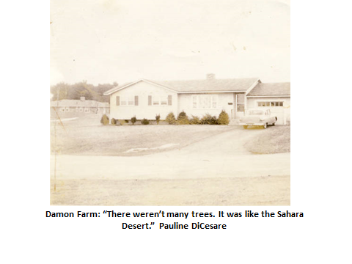Composting is terribly important for the long term health of our soil. Pauline DiCesare told me that when Damon Farms was built, they scrapped off top soil and sold it, leaving nothing but clay and rocks….but by composting her leaves over the years, the soil in that spot has been built up into lovely stuff with worms. In 1993 DEP made bins available to Mass residents in which 500-799 pounds of organics can be composted annually and home composting workshops were given everywhere by Ann McGovern..

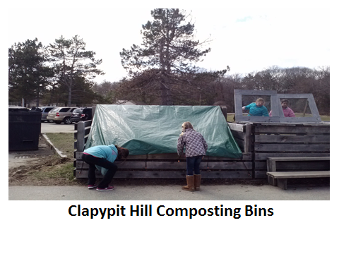
Claypit Hill School’s big compost bins yield about 3 cu. Yards of lovely compost per year for its vegetable garden – using all of the compostable kitchen and cafeteria food scraps plus grounds from Karma Coffee in Sudbury. Same with the Middle School.

There is much room for improving how we dispose of our organic waste, particularly food stuffs from institutions and businesses, landscapers, etc. Large scale composting operations can work for every one and what is great about the process? It just happens. COMPOST HAPPENS. Here are some pics of some facilities.
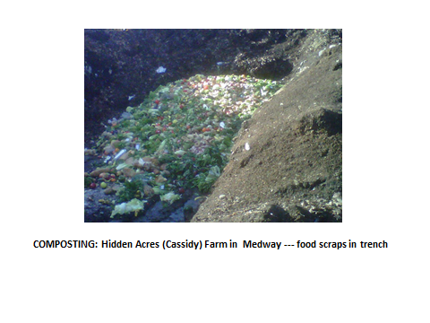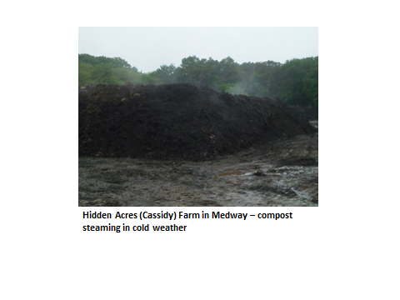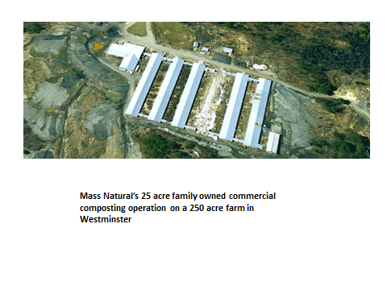
Besides composting, organics can be converted into biogas. 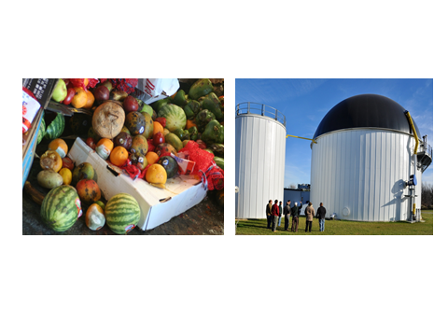
The CRMC Dartmouth Bioenergy Facility is an anaerobic digestion facility located in Dartmouth/New Bedford, Massachusetts. This facility accepts commercial/industrial food wastes, organic sludges, FOG or other liquid or slurried non-hazardous organics. The Bioenergy Facility is the first of its kind to be sited at an operating Massachusetts landfill and the first developed in the state to produce biogas for use in a pre-existing landfill gas-to-energy facility.
What’s happening now in wayland?
5600 households in Wayland (town website), slightly fewer than half of our households are using the transfer station…… 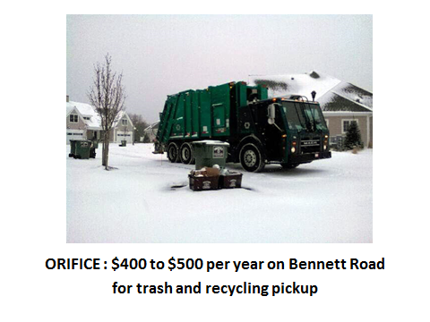Other use one of the private haulers: WM or Orifice or BP. Joe Depaolo of BP says it’s for reasons of convenience, time, and the fact that it is no THE gathering place it was – almost like a town meeting every Saturday. It’s still the place to find campaigners on the stump, see old friends and neighbors, and, the price is right. A dump sticker will cost you $155 plus the cost of the orange bags. And, you get the Give and Take! I’ve gotten back packs, stools, hose, lamps, pots, shovels, and a simply beautiful arrangement of fake magnolias that everyone loves. There’s a fine selection leftover literature, gardeners have planted attractive landscaping and a drought-tolerant perennial demonstration garden. And then there was Moby Disc.!
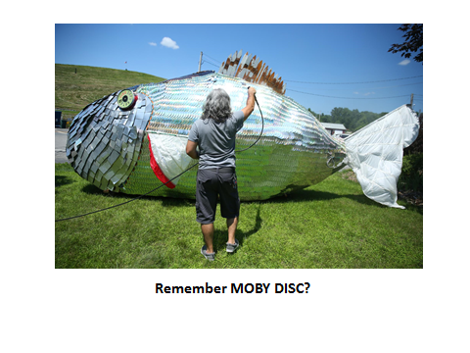
PAYT Orange began in July 2009. This program includes a (much lower) Transfer Station sticker fee and per bag fees that strive to more equitably allocate Transfer Station costs among users. This program also encourages recycling and reduction of solid waste, which, in addition to being "green", will lead to lower costs for both Transfer Station users and the town.

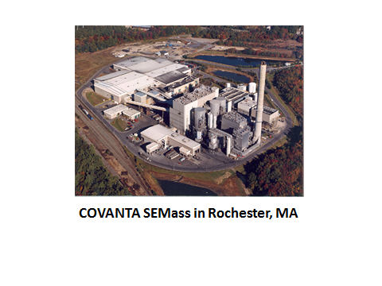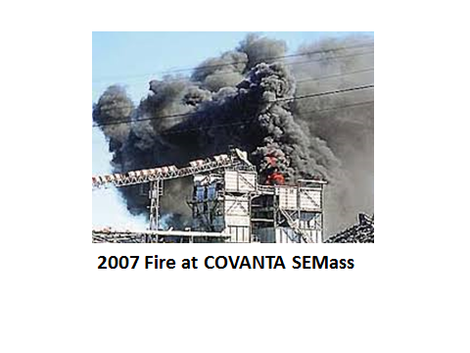

BP Trucking hauls our compacted trash to a transfer station in Hudson. About 1200 tons of trash where the materials are processed and then shipped out to several locations: Most of Wayland’s MSW goes to Covanta in Rochester, MA or Wheelabrator, North Andover. Currently, we pay $76.00 per ton for removal (January 2016) –

Currently our single stream recycling goes to Casella (FCR) in Auburn or Charlestown. In 2015 BP hauled 315 tons of single stream recycling from the towns transfer station; According to Stubby, recycling revenues are way down due to dampening of China market and because of the abundant quantities.
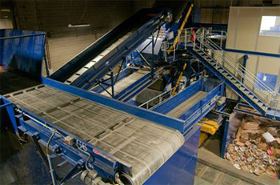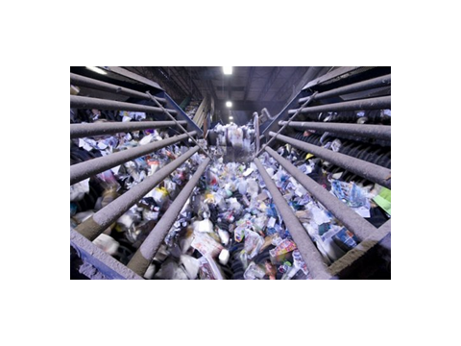
Harvey is building a $5 million one in Westborough from Sweden…

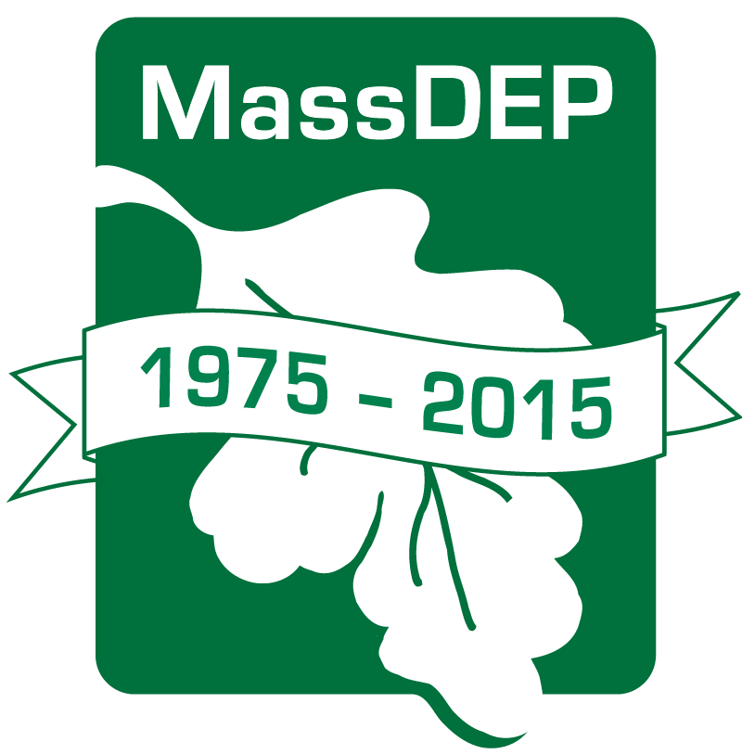 Statewide DEP accomplishments

- Shift towards recycling & composting results in nearly half of state’s solid waste being recycled today compared to only 10% four decades ago.

I’d like to end by telling you that there are now containers for recycling all the old clothing and shoes that are too crummy for the Salvation army….these are at each school and the transfer station. 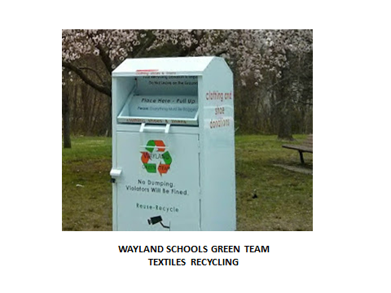

And, finally, there is freecycle. 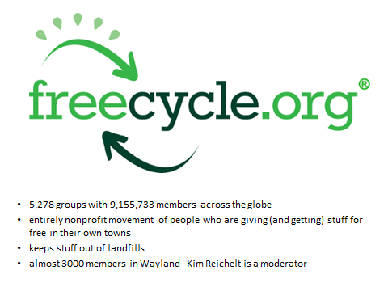

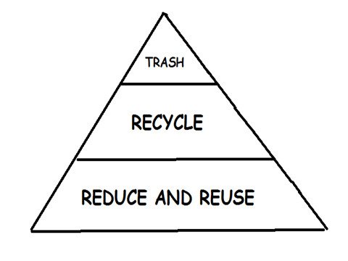

People around the world must change lifestyles and practices to emulate sustainable natural cycles. Setting this goal will help shape a future where all discarded materials are designed to become resources for others to use, and all discharges to land, water or air that are a threat to planetary, human, animal or plant health have been eliminated.

TALKING TRASH:
You are the reason they put instructions on shampoo.
Man, you're like school on Sunday. No Class."
"Hey, ref-- can I pet your seeing eye dog after the game?"
Your mama's so fat, it takes her two trips to haul ass
I'd agree with you but then we'd both be wrong.
"Shut up, you'll never be the man your mother is."
"You'll have better luck trying to score with your sister"
*"I had better luck scoring with your sister."

